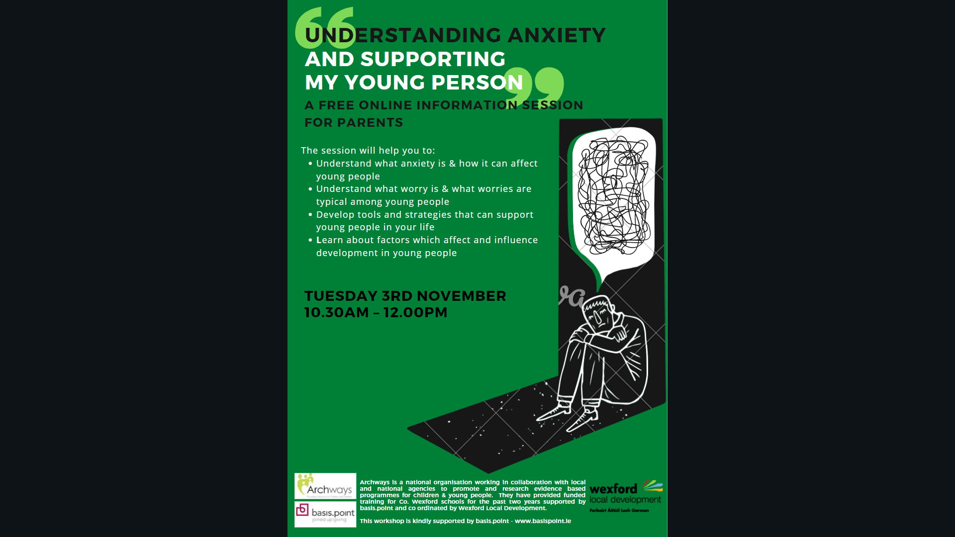

**[CLICK HERE](https://www.eventbrite.ie/e/understanding-anxiety-supporting-my-young-person-tickets-125598308923)**

**[TO BOOK YOUR PLACE](https://www.eventbrite.ie/e/understanding-anxiety-supporting-my-young-person-tickets-125598308923)**