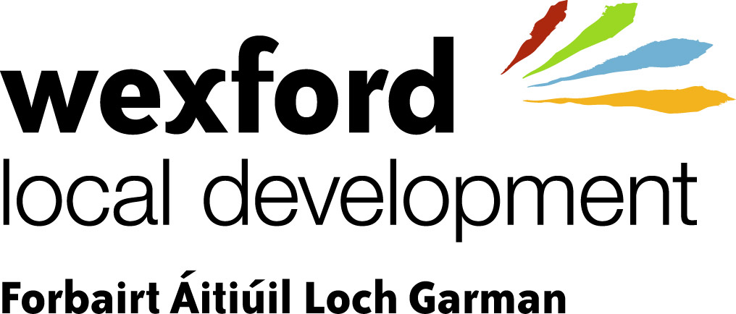

Rural Development Programme 2007 – 2013
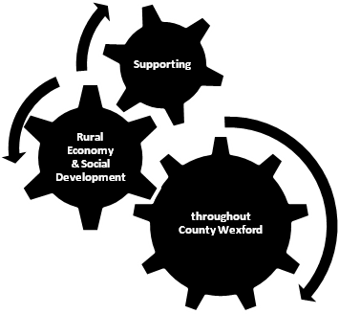

Guidelines

&

Operating rules


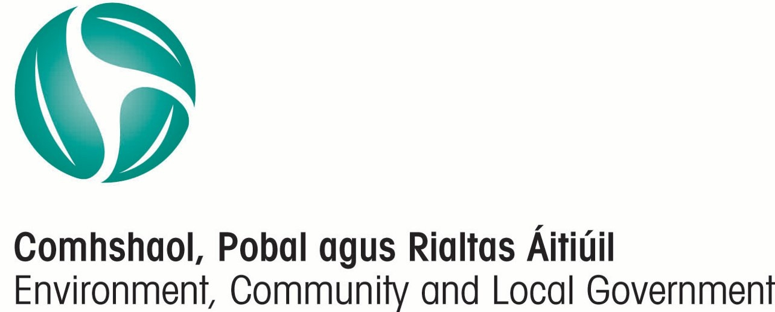

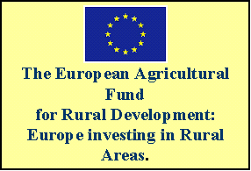
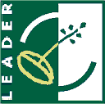

BACKGROUND INFORMATION

WEXFORD LOCAL DEVELOPMENT

Wexford Local Development (WLD) was established in 2009. It is the amalgamation of the three companies, Wexford Organisation for Rural Development (WORD), County Wexford Partnership (CWP) and Wexford Area Partnership (WAP).

As the new local development company for County Wexford, WLD is responsible for the delivery of the new Rural Development Programme 2007-2013.

RURAL DEVELOPMENT PROGRAMME 2007-2013
The aim of the Rural Development Programme (RDP) is:
“To improve the quality of life in rural areas and encourage diversification of economic activity through the implementation of local development strategies”

The programme places a major emphasis on:
- economic activity
- job creation and sustaining of existing jobs
- generation of additional and alternative incomes in rural areas
- implementation of innovative approaches to rural development at a local level

This programme is aimed at all rural dwellers, including the farming community.

The programme will be administered using the LEADER approach, which emphasises a ‘bottom up’ approach to the development of rural areas.

PROGRAMME AREA
The programme is available throughout County Wexford, excluding the Wexford Town Borough Council boundary. However, projects with a countywide remit will be reviewed on an individual basis.

ELIGIBLE ACTIVITIES

ELIGIBLE MEASURES FOR FUNDING
- Diversification into Non-Agricultural Activities
- Support for Business Creation and Development
- Encouragement of Tourism Activities
- Basic Services for the Economy and Rural Population
- Village Renewal and Development
- Conservation and Upgrading of the Rural Heritage
- Training
- Co-Operation Projects
- Analysis & Development

Diversification into Non Agricultural Activities

Aim: To increase the percentage of holdings where the fixed assets of the farm are used for any non-agricultural activity by a member of the farm household for economic gain.

Eligible activities may include:-
- Provision of tourism facilities such as renovation of farm buildings for tourism purposes, walking, cycling, angling, pony trekking, bird watching etc.
- Development of niche tourism and educational services such as arts and crafts, specialty food provision, open farms etc.
- Development of farm shops selling home/locally grown and manufactured products.

Support for Business Creation and Development

Aim: To position rural areas to provide economic activity of sufficient mass to attract people to live and work in those areas.

Eligible activities may include:-
- Selected investment in small rural enterprise space.
- Provision for a range of assistance types for start-up enterprises and the expansion of existing enterprises including the adoption of new technologies.
- Development of innovative products and activities.
- The provision of a range of assistance types for adding value to local products, including support for business networks, collective marketing, local branding initiatives, improved quality and the development of artisan processing facilities.
- Utilisation of local Information Communication Technology capacity, for example centralised online processing of micro enterprise administrative activities, will also be supported.
- Actions to foster rural entrepreneurship particularly combined with support for small-scale research, analysis and development.

Encouragement of Tourism Activities

Aim: To promote the sustainable, regionally balanced tourism potential of all rural areas through the provision of necessary infrastructure and the development of the countryside as a recreational resource for all.

Eligible activities may include:-
- Analysis and provision of infrastructural needs for tourism and countryside recreation.
- Maintenance of vernacular features in a way that protects the heritage such as disused railway lines, canal towpaths, bog roads etc.
- Development of the use of forests for countryside recreation.
- Development of niche tourism such as arts and crafts, speciality food provision, ecotourism, genealogy, archaeology etc.
- Development of the use of the internet and e-commerce facilities in general for the provision of booking and information services to tourists.
- Tourism related Equine Projects

Basic Services for the Economy and Rural Population

Aim: To identify and provide appropriate cultural and leisure facilities to local communities, not otherwise available to them.

Eligible activities may include:-
- Amenity and leisure facilities.
- Support for cultural activities.
- Certain arts facilities.
- General community and recreational infrastructure.
- Innovative activities in local communities such as social and information networks.

Village Renewal and Development

Aim: To provide appropriate supports to enhance the economic and social attractiveness of villages, small towns and the surrounding countryside.

Eligible activities may include:-
- Environmental upgrading – parks, civic areas, river walks etc.
- Access facilities to amenities.
- Public utilities such as street lighting etc.
- General surface upgrading and renovation of relevant derelict buildings.
- Farmers markets.
- Other small-scale actions.

Conservation and Upgrading of the Rural Heritage

Aim: To provide an integrated approach for the protection of the local heritage through a number of related preservation actions, complimented by a range of initiatives designed to develop the sustainable economic contribution of the natural heritage.

Eligible activities may include:-
- Actions to preserve and develop vernacular architecture, crafts, archaeology, cultural traditions etc.
- Integrated plans for the restoration and development of locally significant natural areas, features and areas of environmental significance.
- Community environmental actions to protect and restore the amenity value of local water resources and high value nature areas.
- Other environmental initiatives aimed at waste reduction.
- Alternative or renewable energy actions addressing suitability of new technologies to meet community energy needs, awareness actions for community groups and under certain conditions, capital assistance to community groups adopting such technology.

Training and Information

Aim: To equip rural dwellers and communities with the appropriate range of skills and training to derive maximum social and economic benefit from the initiatives available under the RDP.

Eligible activities may include:-
- Provision of general/specialised training courses and development of appropriate training facilities linked to the increased use of know-how and new technologies.
- Provision of flexible learning opportunities in new technology.
- Development of training facilities in rural areas (fixed/mobile).
- Facilitation of distant learning through the use of new technologies.
- Provision of relevant training courses to those wishing to add value to local products, in particular by facilitating access to markets for small producers.
- Developing the capacity of rural dwellers to use Information Communication Technology (ICT) including internet and broadband to access e-services.

Co-Operation Projects

Transnational and inter-territorial co-operation projects are supported under this measure. Co-operation must consist of a joint project between the groups involved demonstrating a genuine added value for the territories concerned.

Cooperation Projects Include:-
- Inter-territorial (co-operation with groups/companies within Ireland).
- Trans-national (co-operation with groups/companies within EU Member States, EU candidate states and EEA states).

Analysis and Development

This measure includes support for feasibility studies, development of prototypes, community plans and business plans for eligible RDP activities. These projects will only be supported where the need is essential. A copy of the analysis and development report/results must be made available to WLD.

INELIGIBLE ACTIVITIES

Grant aid shall not be awarded or paid in respect of the following mainstream categories:-
- Agriculture / Horticulture | - Healthcare Activities
- Fisheries | - Housing
- Childcare | - Greyhound Industry
- Education

Grant aid shall not be awarded in respect of the following activities:
- Conventional motor vehicles, including cars, industrial/farm/construction vehicles, vans.
- Conventional retail operations.
- Courses of instruction or training which form the part of normal education programme or systems at secondary or higher levels with the exception of distance learning.
- Loans.
- Mainstream activities of sporting clubs and organizations.
- Nursing homes.
- Planning application fees or the purchase of land or buildings.
- Second-hand equipment.
- Working capital (including stock).
- Renovation of derelict traditional farm buildings.
- Construction and protection of National Monuments.
- Water, sewage and major road works.

Deadweight & Displacement
- Projects will not be eligible for funding if they are capable of proceeding without grant aid.
- Funding cannot be provided if it will result in the displacement of a similar enterprise elsewhere.

The ‘de minimis’ Rule
The overall limit of ‘de minimis’ aid is €200,000 in any three year period. The ‘de minimis’ rule applies to both the project and the promoter. The ‘de minimis’ rule applies to all initiatives including community initiatives involving economic activity.

Ineligible Costs
The ‘normal’ business expenses of promoters are not eligible for grant aid. For example, phone, postage, entertainment costs, administration, insurance costs etc.

RATES OF AID & MATCHING FUNDS

 | Community Projects |  | Private Enterprise Projects
Type of Project | Rate | Maximum Grant | Rate | Maximum Grant
Capital | 75% | €150,000 | 75% | €150,000
Training | 100% | €150,000 | 75% | €150,000
Analysis & Development | 90% | €30,000 | 75% | €30,000
In exceptional circumstances, subject to prior approval grant aid up to €200,000 and €500,000 may be awarded to certain projects.

Promoters Matching Funds
The project promoter must provide evidence private matching funding e.g. savings, loan etc. for their project. It is imperative that the promoter demonstrates that adequate resources or bridging finance facilities are in place to deliver the project. Projects that do not have this in place may be considered ineligible. At a minimum, where phase payments have been agreed with the promoter, evidence of 30% of the total project costs must be provided.

Capital Projects
Eligible costs for projects involving capital investment are:
- Construction.
- Purchase of new machinery and equipment.
- General costs, such as architects’, engineers’ and consultants’ fees up to a ceiling of 12% of the total capital costs.

Voluntary Labour (Community Projects Only)
An upper limit rate of €25 per hour may be allowable for voluntary labour hours contributed on community projects. Voluntary Labour is an acceptable source of matching funds for community projects only. All details of the voluntary labour involved on a project must be agreed in advance with your Project Officer.

Donations (Community Projects Only)

Some types of donations may be reckoned as private matching funds.

Funding From Other Sources
Under no circumstances may other sources of public funding be used as a source of private matching funding.

POINTS TO NOTE
Quotation Submission

Original quotations are required as follows:
Items of Expenditure | Construction Works | Items of Expenditure | Supplies & Services
Up to €5,000 | 1 quotation | Up to €5,000 | 1 quotation
€5,001 to €25,000 | 3 quotations | €5,001 to €25,000 | 3 quotations
€25,001 to €50,000 | 5 quotations | €25,001 to €50,000 | *Must go to tender
€50,001 or over | *Must go to tender | €50,001 or over | *Must go to tender

*For information on tendering procedures please visit the following websites:
www.etenders.gov.ie or www.constructionprocurement.gov.ie

Leasing
Leasing or hire purchase of plant or equipment is only allowable where the lease/hire purchase agreement provides for the actual transfer of ownership to the lessee or hirer.

Duplication of Funding
To minimise the risk of duplicate funding, a procedure of exchanging information between WLD and other funding agencies e.g. Wexford County Enterprise Board, will be strictly adhered to.

Equality of Opportunities
The equality of opportunity will be taken into account when assessing applications for aid and WLD will not grant aid a project whose promoter operates (or is considered likely to operate after the project is completed), a policy of discrimination. This applies even if the discrimination is not complained of.

Appeals
All promoters have a right of appeal in respect of all grant decisions by WLD.

EVIDENCE OF TITLE/LEASEHOLD OF PROPERTY
Promoters must provide evidence of Title/Leasehold in respect of capital projects involving land/property.

Owned Land/Property: A recently certified copy of the Folio/Stamped Deed of Conveyance/Agreement, and map, showing the promoter as owner.

Leased Land/Property: A certified original or copy (certified by a solicitor to be a true copy) must be provided in all cases. The duration and details of the lease should be discussed with your project officer.

PROJECT ASSESSMENT PROCESS

Initial Project Assessment
Your project will be evaluated initially by a staff member of WLD who will check whether your project is eligible against the operating rules. If your project is not eligible for grant aid our staff will offer advice on other agencies which may be able to help you.

Project evaluation will also include reviewing the application form and the accompanying information and a meeting with the promoter.

Project Evaluation
Only fully documented applications for grant aid will be presented to an Advisory Council for consideration. The Advisory Council will make a recommendation to the Board of WLD for a decision on your application. The Board may approve, reject or defer an application.

Valid Commitment of Aid
A valid commitment of grant aid exists only when:
- The Board of WLD has made its decision AND
- A detailed letter of offer and contract has been issued to the promoter AND
- The signed letter of offer and contract has been received in the offices of WLD.

Project Commencement Date

Project costs incurred prior to receipt of the signed letter of offer and contract in the offices of WLD will cause your project to be ineligible.

Grant Offer: The promoter must comply with the conditions presented in the Letter of Offer/Contract.

Increase in Project Costs
If project costs prove higher than that stated on the grant aid letter of offer, no increase in grant aid can be given to cover these additional costs.

Project Completion Dates
Project completion deadline dates should be strictly adhered to and will only be extended in exceptional circumstances by the Board of WLD.

Changes to Operating Rules
The Department of Environment Community & Local Government and/or WLD reserves the right to make additions and amendments to these rules in light of changing circumstances over the course of the programme. Any changes will be notified to promoters in writing, where applicable.

GRANT PAYMENTS
the project must be paid for in full by the promoter before the grant payment can be made.

Grant Payments
Grant payments can only be made when:-
- The project is completed AND
- A fully documented and signed claim form is submitted AND
- Satisfactory inspection by a WLD staff member
- Completion of Performance Indicator report
Advance payments will not be made under any circumstance.

Phased Payments
Up to 5 phased payments are allowed for any one project subject to prior approval. The first phased payment can only issue when the project has been 30% completed i.e. submission of paid invoices (and other associated paperwork) to the value of 30% of total project costs. Payments will be calculated at the percentage rate of grant aid approved.

In the case of capital projects, the first phased payment cannot issue until written verification has been received from an independently qualified person that the overall project is at least 30% complete (at promoters cost).

Cash Ceiling
Payments made by cash by a promoter may NOT exceed €1000.00 in total. Any amount exceeding this threshold and included in a claim for grant aid shall be considered ineligible and shall be de-committed.

Original Documentation
Original documents are required in ALL cases to support a grant claim. All original documents will be returned to the promoter once the claim has been processed but might be required from him / her at a later stage in the event of an audit or other official visit to the project.

Grant Claw Back
WLD will make it a condition of offer of grant aid to a promoter that:-
- If the beneficiary goes into liquidation or receivership within a period of 5 years of the date of the final grant payment, the grant must be repaid in full.
- If any grant aided assets are sold, leased or changed within 5 years of the date of grant payment, without the express approval of WLD, the grant must be repaid in full.

Extension to Contract
In certain circumstances and upon request by the promoter, project draw down dates may be extended, but should not be extended by more than 3 months at a time. A clear rational for the extension must be submitted in writing by the promoter prior to the Contract expiry date.

Taxation

VAT
For VAT to be eligible for grant aid purposes, the promoter will need to prove that they are not registered for VAT by completing the enclosed VAT Declaration form.

Tax Clearance Procedures
Project Promoters, Contractors/Suppliers, Trainers etc. must provide evidence of being tax compliant for grant aid purposes. Please discuss with your Project Officer.
IMPORTANT: In cases where the necessary tax declarations/certificates cannot be produced payment will be withheld. Non-resident suppliers/contractors must also apply for a tax clearance certificate in respect of payments above the threshold.

Insurance
The promoter is required to affect employee’s liability insurance, public liability insurance and insurance against fire damage to buildings, equipment and other facilities. The Minister and the Department of Environment Community and Local Government must be indemnified on the policy.

Information and Publicity
Project promoters are required to erect plaques acknowledging the assistance of the EU and EAFRD. These plaques will be supplied by WLD. In leaflets, booklets, websites and any other publications that receive grant assistance must include the following information and logos:

This Project has been supported by
Tá tacaíocht ag an togra seo όn
‘The European Agricultural Fund for Rural Development: Europe investing in rural areas’

Further details on the above can be obtained from your local Project Officer

NATIONAL RURAL DEVELOPMENT PROGRAMME
CONTACT DETAILS

For All Correspondence:
Wexford Local Development
Spawell Road
Wexford
Tel: 053-9155800
Website: www.wld.ie
Email: info@wld.ie

PROJECT OFFICER CONTACT DETAILS:

Helena Dempsey Tel: 053 – 9155866
Mob: 087 – 1737502
Email: hdempsey@wld.ie

Séamus Doran Tel: 053 – 9155881
Mob: 085-1737504
E-mail: sdoran@wld.ie

Tom Bermingham Tel: 053 – 9155856
Mob: 085 – 8239314
E-mail: tbermingham@wld.ie

Eileen Dake Tel: 053 – 9155812
Mob: 087 – 6225993
Email: edake@wld.ie

